ADINA ISRAN
BATCH-42
2303A52222
Error Debugging with AI: Systematic approaches to finding and fixing bugs

Task 1: Fixing Syntax Errors
Scenario
You are reviewing a Python program where a basic function definition contains a syntax error.
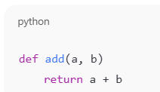
Requirements
• Provide a Python function add(a, b) with a missing colon
• Use an AI tool to detect the syntax error
• Allow AI to correct the function definition
• Observe how AI explains the syntax issue
Expected Output
• Corrected function with proper syntax
• Syntax error resolved successfully
• AI-generated explanation of the fix
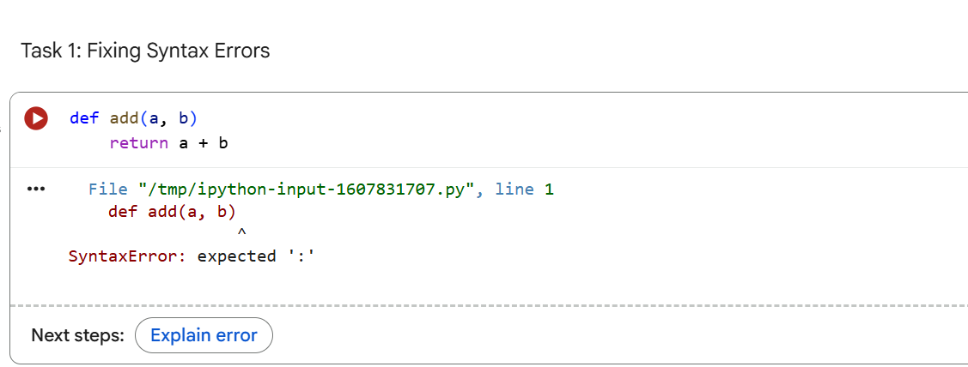

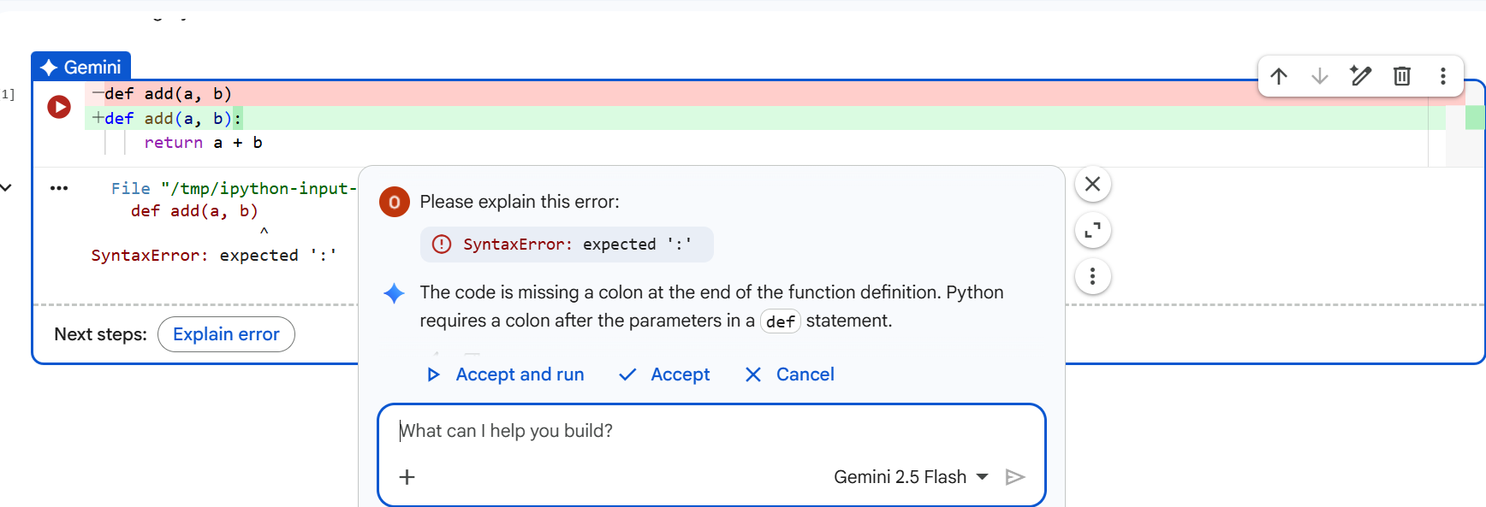

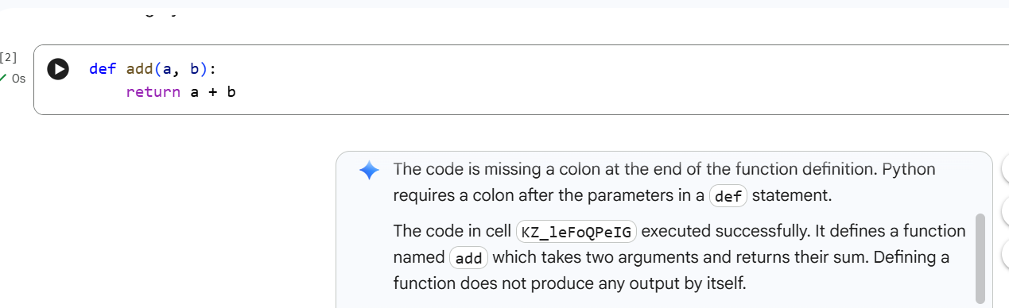

JUSTIFICATION:
The AI acted as a second pair of eyes, instantly spotting the missing colon that human eyes often skip over. It didn't just flag the error; it explained that the colon is Python's way of saying "the instructions start here," helping the developer understand the language's structural rhythm. By providing the fix, it turned a frustrating halt into a quick, five-second correction.

Task 2: Debugging Logic Errors in Loops
Scenario
You are debugging a loop that runs infinitely due to a logical mistake.
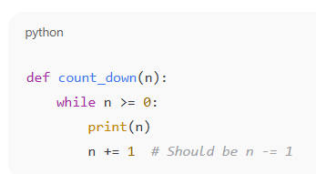

Requirements
• Provide a loop with an increment or decrement error
• Use AI to identify the cause of infinite iteration
• Let AI fix the loop logic
• Analyze the corrected loop behavior

Expected Output
• Infinite loop issue resolved
• Correct increment/decrement logic applied
• AI explanation of the logic error

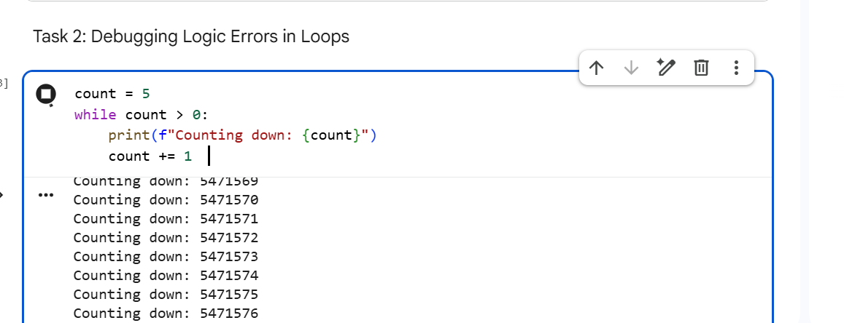

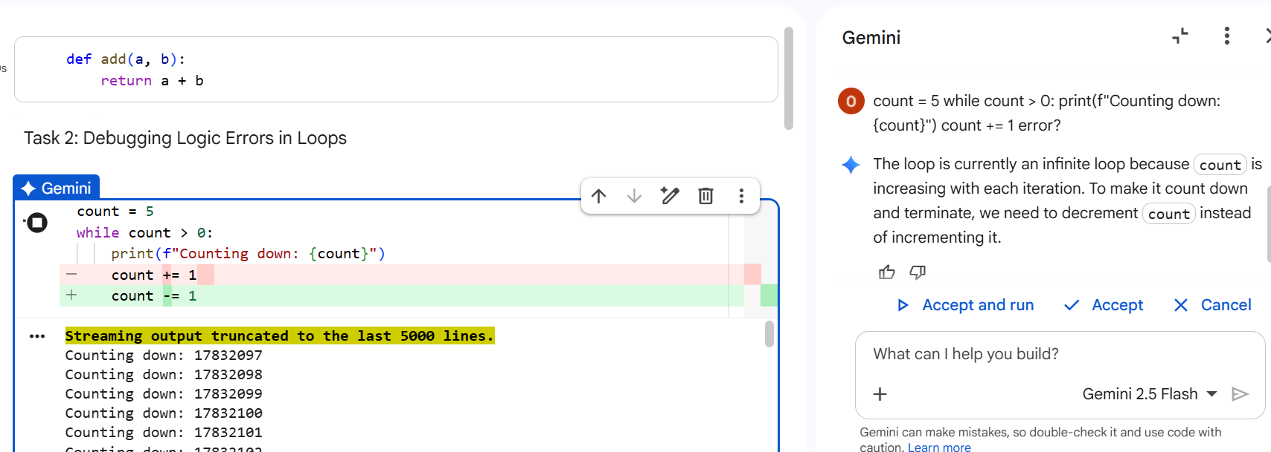

O

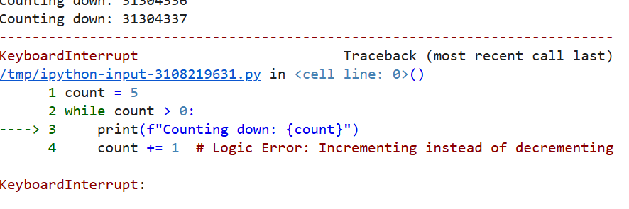

OUTPUT:
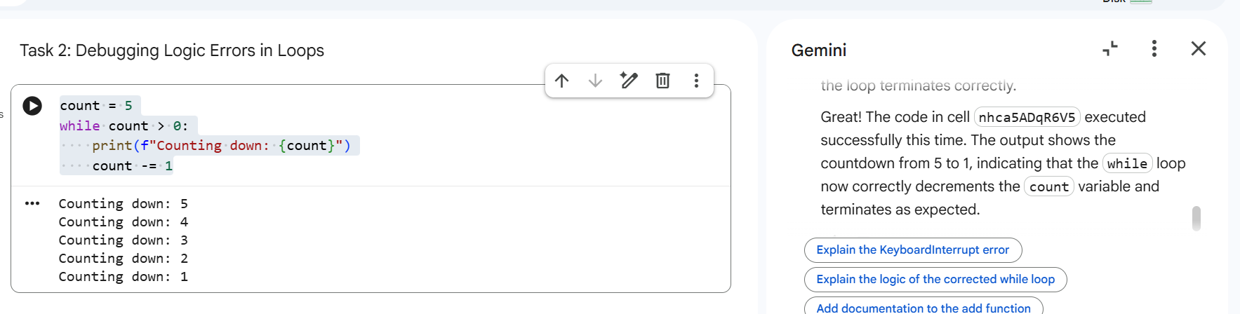

JUSTIFICATION:
For the infinite loop, the AI performed a "mental simulation" of the code to see where it would end up. It recognized that while the code was written correctly, the logic was headed in the wrong direction, like a car driving the wrong way on a one-way street. The AI then nudged the developer to flip the increment to a decrement, ensuring the program actually reaches its finish line.

Task 3: Handling Runtime Errors (Division by Zero)
Scenario
A Python function crashes during execution due to a division by zero error.
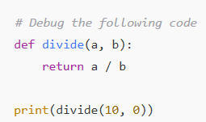

Requirements
• Provide a function that performs division without validation
• Use AI to identify the runtime error
• Let AI add try-except blocks for safe execution
• Review AI’s error-handling approach

Expected Output
• Function executes safely without crashing
• Division by zero handled using try-except
• Clear AI-generated explanation of runtime error handling

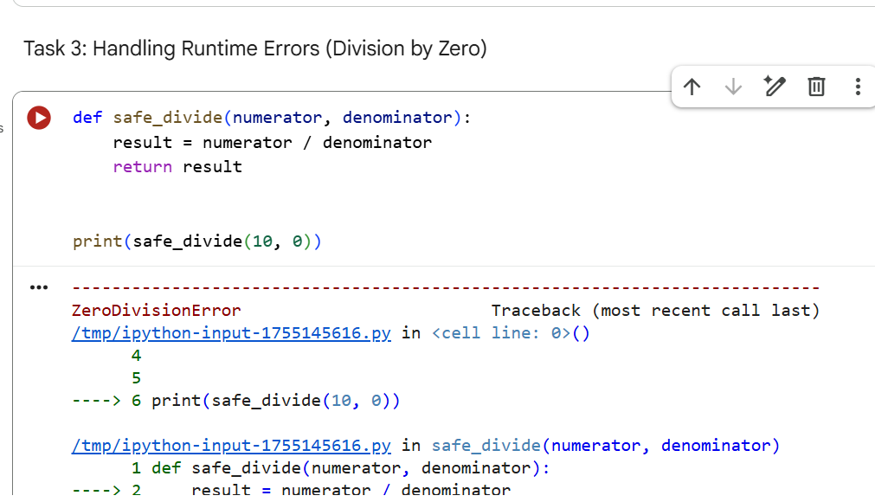

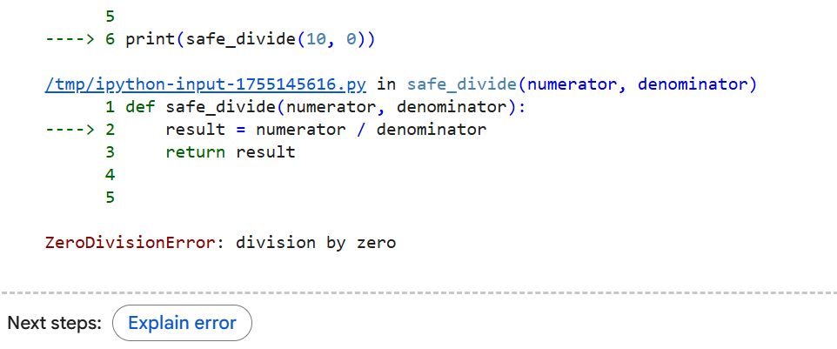

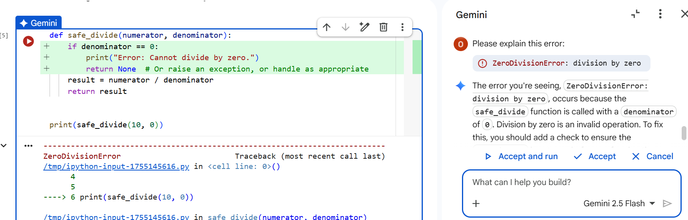

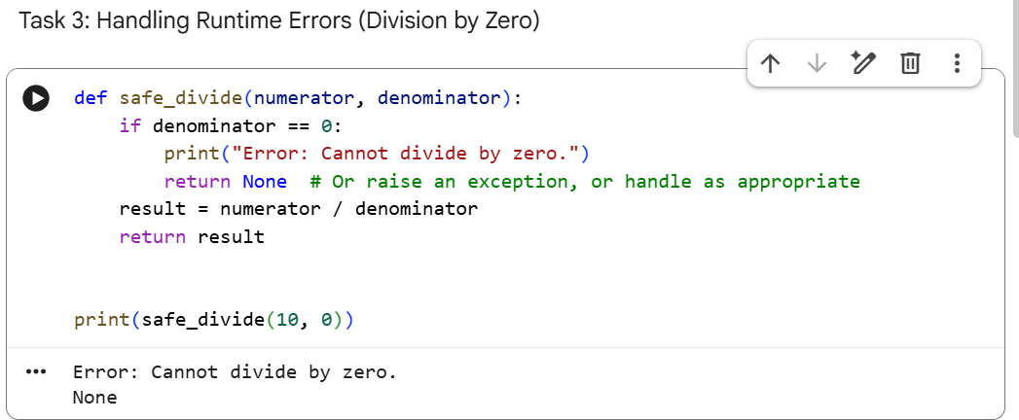

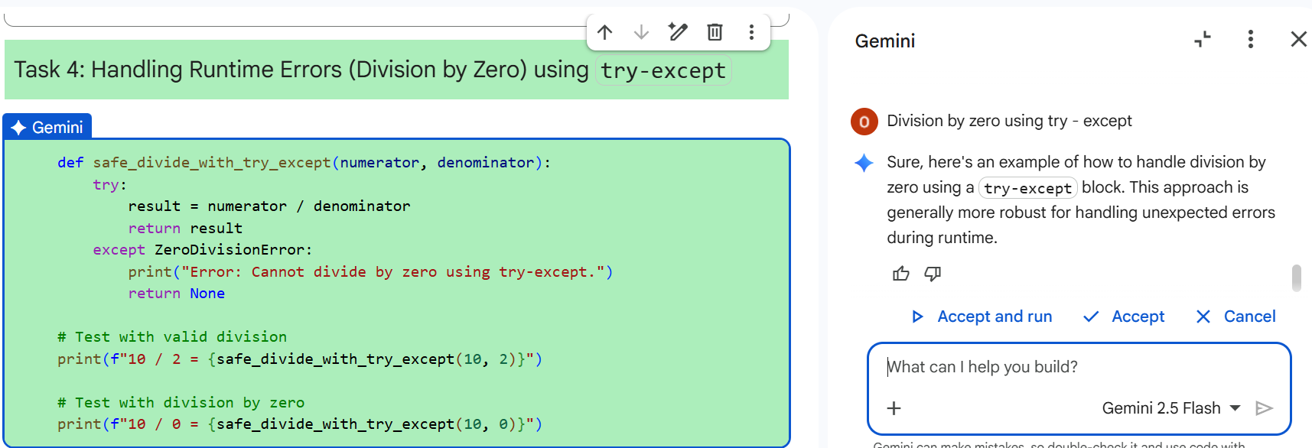

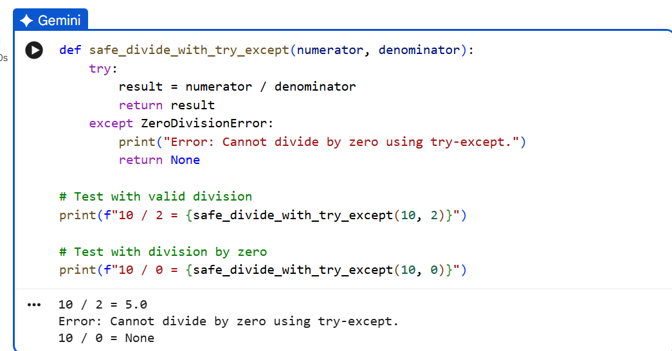

JUSTIFICATION:
The AI served as a safety inspector here, identifying a "hidden trap" where a zero input would crash the whole system. Instead of waiting for the crash to happen, it suggested a try-except block to act as a safety net. This moved the code from being "fragile" to "resilient," showing the developer how to handle the unexpected without the program falling apart.

Task 4: Debugging Class Definition Errors
Scenario
You are given a faulty Python class where the constructor is incorrectly defined.
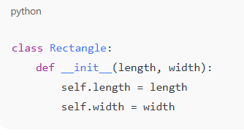

Requirements
• Provide a class definition with missing self-parameter
• Use AI to identify the issue in the __init__() method
• Allow AI to correct the class definition
• Understand why self is required

Expected Output
• Corrected __init__() method
• Proper use of self in class definition
• AI explanation of object-oriented error
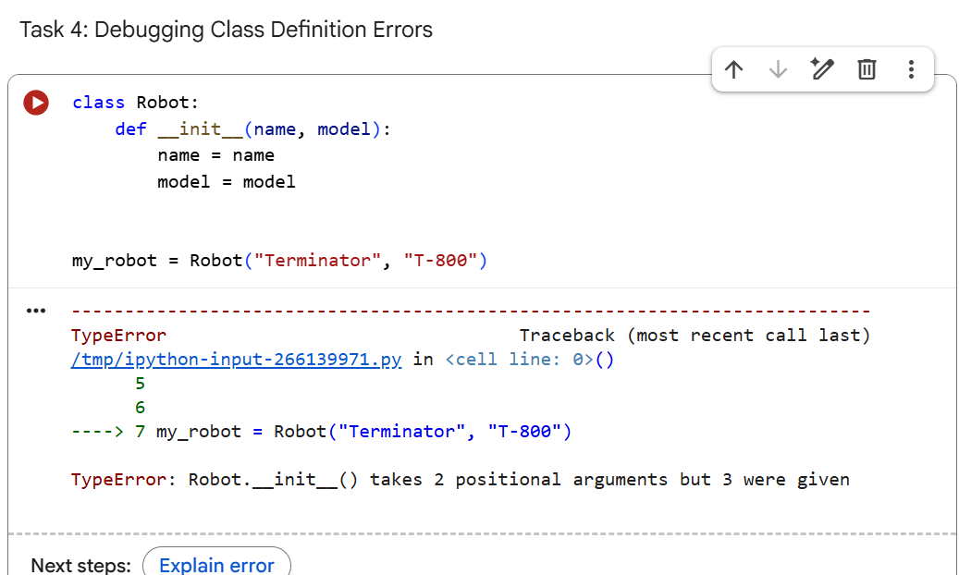

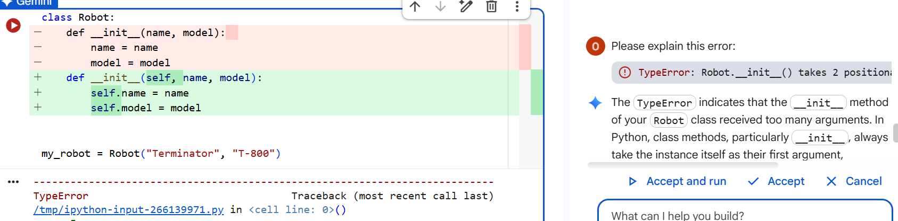

OUTPUT:
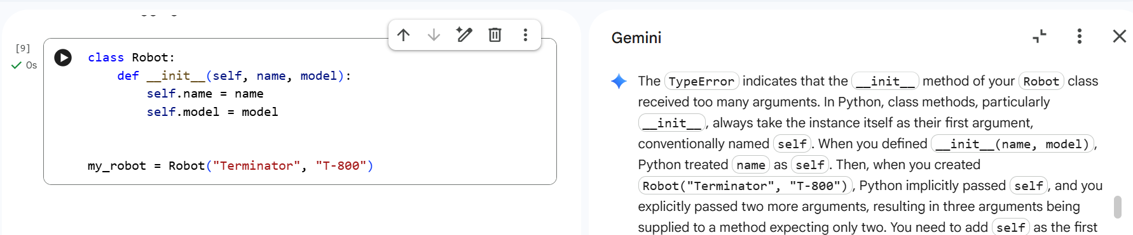

JUSTIFICATION:
In the class task, the AI functioned as a translator for Python’s specific "Object-Oriented" rules. It identified that the missing self was preventing the object from recognizing its own data, a common hurdle for many beginners. By adding self back in, the AI demonstrated how to properly "connect" an object’s identity to its attributes, making the code much more organized.

Task 5: Resolving Index Errors in Lists
Scenario
A program crashes when accessing an invalid index in a list.
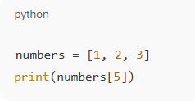

Requirements
• Provide code that accesses an out-of-range list index
• Use AI to identify the Index Error
• Let AI suggest safe access methods
• Apply bounds checking or exception handling
Expected Output
• Index error resolved
• Safe list access logic implemented
• AI suggestion using length checks or exception handling

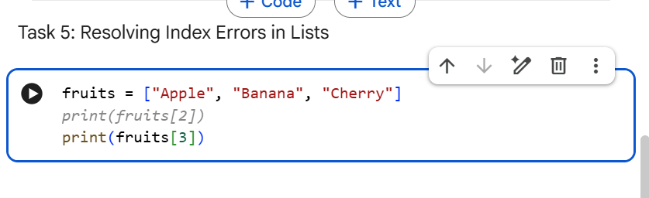
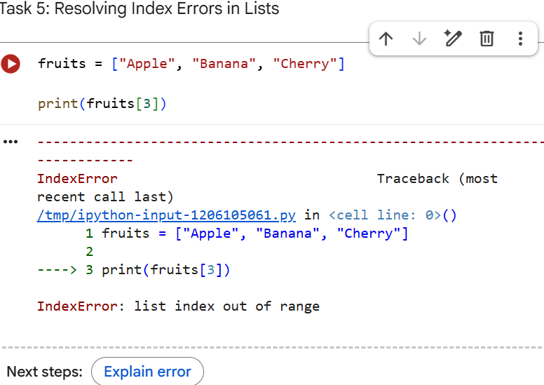

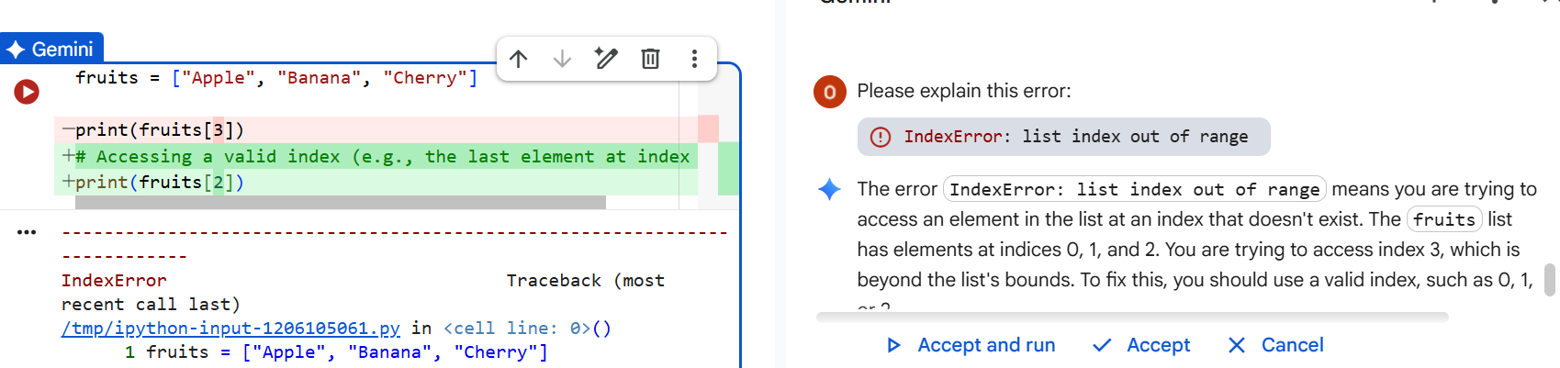

OUTPUT:
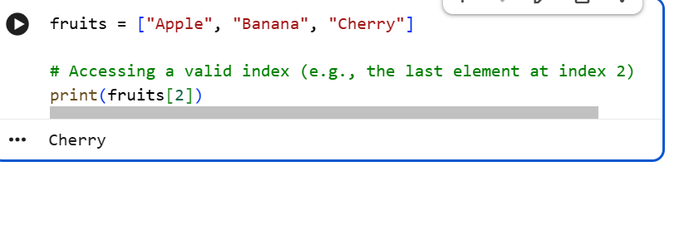
JUSTIFICATION:
The AI acted as a boundary guard, pointing out that the code was trying to reach for a list item that simply didn't exist. It simplified the concept of "zero-based indexing" and offered safe alternatives like bounds checking to prevent future crashes. This approach taught the developer to always verify the "size of the container" before reaching inside for data.

